SYNTHESIS AND REACTIVITY OF β -KETOSULFIDES IN DEEP
EUTECTIC SOLVENTS

Chiara Falcini^{1*}; Rosario Férnandez¹ and Gonzalo de Gonzalo¹

¹ Department of Organic Chemistry, University of Seville, Seville, Spain
* Corresponding author: cfalcini@us.es

Deep eutectic Solvents (DESs) have appeared in the recent years as an appealingalternative to classical organic solvents, due to their valuable environmental properties [1]. In addition, these compounds, formed by the combination of one hydrogen bond donor with a hydrogen bond acceptor at a defined stoichiometric ratio, present other valuable activities not only as a reaction medium [2]. β-Ketosulfide motif constitutes an interesting organic framework, widely present in natural products and it presents interest in biological and pharmaceutical chemistry [3]. These compounds can be obtained from thiols or other sulfur sources, such as disulfides or silylsulfides employing metals or organocatalysts [4]. Recently, the synthesis of β-ketosulfides has been described employing lipases from from β-alkylsulfide enol esters, but these compounds were obtained using dimethylformamide (DMF) as solvent [5]. The preparation of β-ketosulfides employing DESs will be discussed herein, showing a novel multicomponent one pot reaction under mild conditions employing 2-bromoacetophenone as starting material. The obtained β-ketosulfides have been reduced into optically active β-hydroxyulfides employing alcohol dehydrogenases also in presence of DESs (Scheme 1).

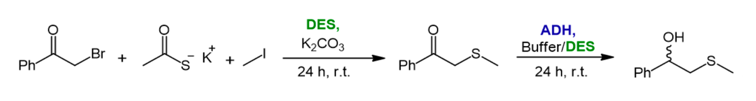
Scheme 1: Multicomponent one pot reaction to prepare β-ketosulfides and bioreduction to optically active β-hydroxyulfides.

[1] Smith, E. L.; Abbott, A. P.; Ryder, K. S., Deep Eutectic Solvents (DESs) and their applications. Chemical
Reviews 2014, 114, 11060–11082.
[2] Falcini, C. and de Gonzalo, G., Deep Eutectic Solvents as Catalysts in the Synthesis of Active Pharmaceutical
Ingredients and Precursors. Catalysts 2024, 14, 120.
[3] Perrey, D. A.; Narla, R. K.; Uckun, F. M. Bioorg., Cysteine Chloromethyl and Diazomethyl Ketone Derivatives
with Potent Anti-Leukemic Activity. Bioorganic & Medicinal Chemistry Letters 2000, 10, 547–549.
[4] Vaquer, A. F.; Frongia, A.; Secci, F.; Tuveri, E., Disulfide-based metal-free a-sulfanylation of Ketones. RSC
Advances 2015, 5, 96695–96704.
[5] Heredia A, A.; López-Vidal, M. G.; Kurina-Sanz, M.; Bisogno R, F.; Peñéñory B, A., Thiol-free
chemoenzymatic synthesis of β-ketosulfides. Beilstein Journal of Organic Chemistry 2019, 15, 378–387.

