**SHORT PRESENTATION Title.**

Firstauthor1*; Secondauthor2 and Lastauthor3

1 First author affiliation, City and Country

2 Second author affiliation, City and Country

3 Last author affiliation, City and Country

* Corresponding author: email@corresponding.author

Title:upper case, bold, centered; size: 14 pt. Authors' name(s): centered (separated with semicolon in case of multiple authors); size: 12 pt. Affiliation(s) and full address(es):in italics, centered; size: 10 pt. In case of multiple affiliations, please use 1, 2, 3, etc. in superscript (do not use automatic tools). E-mail address of the main author: in italics, centred; size: 10 pt. Please leave two blank lines between the e-mail address and the body of the abstract.

In the main text (Times New Roman, 12 pt, justified), summarise in a very short and concise form the main achievements of your work. The lenght of abstract is max. one A4 page with margins (left, right, top, bottom) of 2.5 cm. Adhere to the line spacing (exactly 14 pt) given in this document.

Insert figures or schemes directly into the text. Please provide the text, figures and schemes (if any) with suitably high contrast and resolution.

*FIGURE EXAMPLE:*

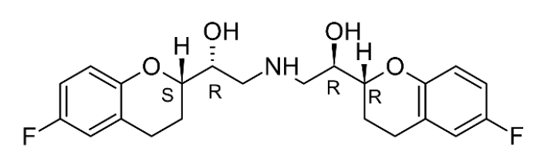

**Figure 1:** (*S,R,R,R*)-**1**.

Please name your abstract as <**firstname_surname.doc**> (file format: rtf or MS Word doc, docx). Please do not use accents in your filename.

References should be placed at the end of the text (size: 10 pt). and refered to with numbers in superscript.[1,2] Please do not use any automatic tool for inserting references.

*REFERENCE EXAMPLE:*

[1] Martin, J; Puech, A.-J.; Brochet, D.; Soubrié, P.; Simon, P., Comparison of clenbuterol enantiomers using four psychopharmacological tests sensitive to β-agonists. *European Journal of Pharmacology* **1985,** *117*, 127-129.